Disability Justice in Historic Preservation

Preservation League of New York State

October 19, 2022, online via zoom

Nicole Belolan, PhD, nbelolan@gmail.com

Access Copy of Remarks

I am a white woman with long brown hair and glasses my dining room. I do not identify as disabled. I am currently dealing with a cold, so please bear with my voice and congestion. Thank you for having me here today. It’s an honor to be a part of this panel. And thank you the Preservation League of NY State –especially Katy Peace—for featuring disability justice.
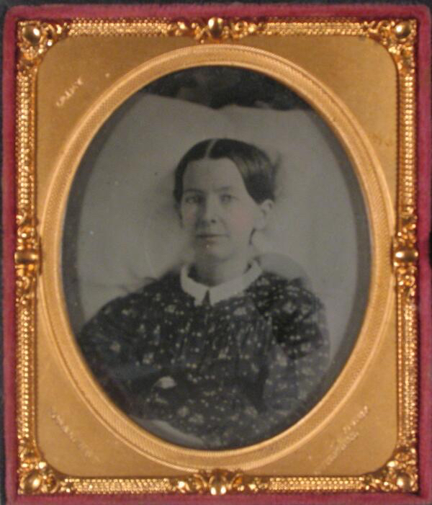
Figure 1. Ambrotype of Ann Warder. (Haverford College Quaker and Special Collections, Haverford, PA)

I’m going to talk a bit today about how I got interested in advocating for disabled people in the cultural heritage sector.
My interest in disability justice developed from my work as an historian. I got interested in disability history through my research on a woman named Ann Warder who lived in the first half on the nineteenth century in Philadelphia. I was interested in explaining why her needlework (called Berlin work) was important to her. It’s a type of needlework people don’t like today, so I wanted to explain why it was important to people in the period. It turns out she used her needlework to stay in touch with friends and family while she was chronically ill at home. He invalidism got me thinking...what types of objects did people in early America use to live with and manage disability?

So that lead to my research on physical disability and material culture—chairs with wheels, crutches, artificial limbs—in early America, especially between 1700 and 1840. Don’t just study the artifacts themselves but entire environments- such as the home. Disabled people then and now don’t just use disability stuff – they use and interact with everything. What I found is that disabled people were relatively well-integrated into everyday life, which was counter to what most people assumed 1700s and early 1800s. There are many great material and visual manifestations of this.

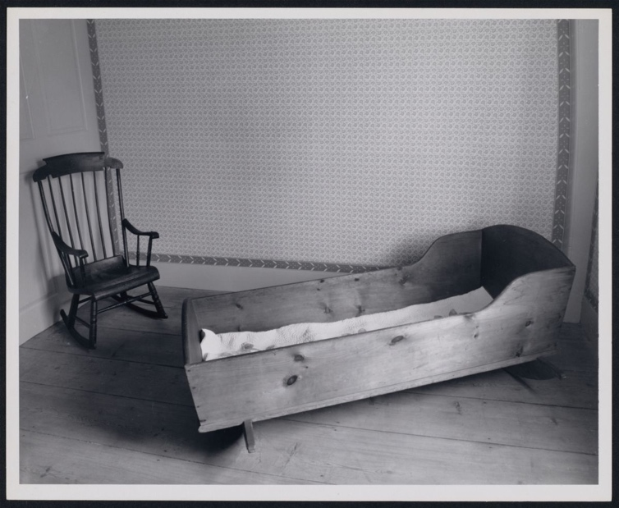
Figure 2. Martha Ward's Cradle and a Boston Rocker, photographed in the 1970s, General Artemas Ward House Museum, HU4098.16 (The President and Fellows of Harvard College.)
For example, people used what we refer to today as an adult cradle. It looked like a large baby cradle. Disabled people with a variety of disabilities used these mobile bedsteads to remain integrated into family life at home (rather than away from household activity in a more private bedroom).

I kept my research going and completed my PhD. In the meantime, I had also been working for the Museum Studies program at the University of Delaware on developing and teaching workshops for small museums and historic sites on all sorts of topics ranging from podcasting to collections management.

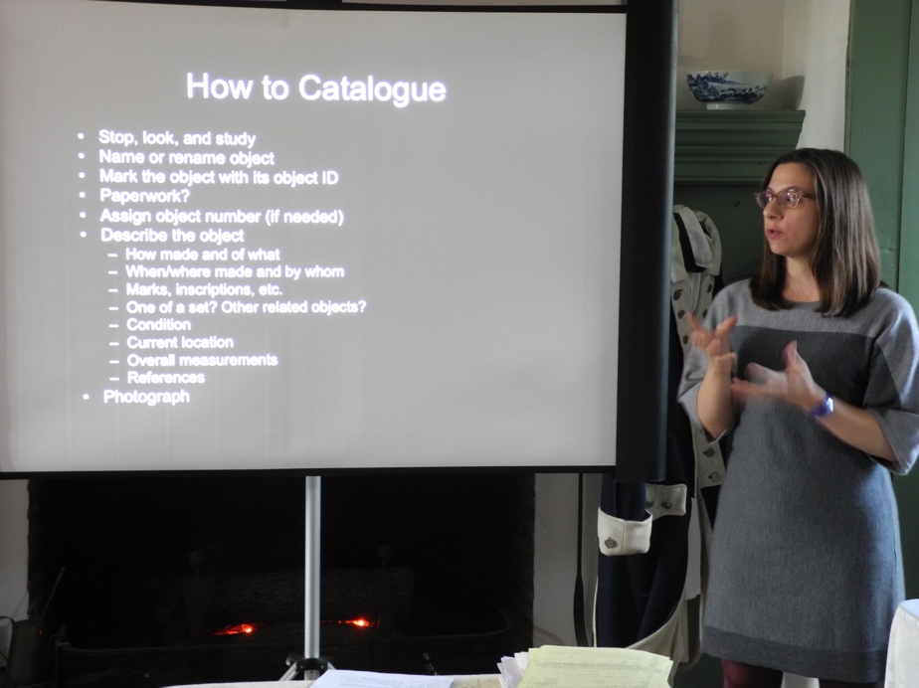
Figure 3. Presenter giving a workshop on how to catalogue museum collections in 2014 at the Hale-Byrnes House in Delaware.
This particular series of workshops emphasized making small changes toward larger goals. So, in a small museum context with limited resources, this might mean taking collections artifacts out of basements and putting them on the ground floor on a shelf. I got pretty good at facilitating this sort of professional development (and still do that as part of my job).

In the meantime, as I started giving papers at conferences and meeting more people involved in the disability history community, I started learning a whole new set of skills and a whole new way of approaching the world. I learned about providing access copies for talks and insisting people use the microphone. I learned about asking about people’s access needs ahead of time and not making them have to do it themselves.

And I realized that the small museum community I was serving with these collections management workshops, for example, could really benefit from these new access-related skills I was learning! I started talking to groups about access and inclusion. And that’s when one workshop or talk started leading to another, and I started framing these workshops and talks in such a way that I thought would help these groups wrap their minds around the work: preservation and access for small museums and historic sites, places that do the work of historic preservation. Usually means providing access to collections for research. A historic house for a tour. But I wanted to make sure people access could also be about disability. And not just disability, but other identities related to race, class, and gender.

And as I started doing this advocacy, I realized I wasn’t doing a good job explaining the historical roots of WHY this access and inclusion was necessary. So I started adding in some history to the work. And this is where I was able to bring in my expertise in early American disability history. Because we often don’t think about the needs of disabled people today, I also started talking about why. One thing that stands in our way is time, and the ableist things people and institutions and governments did in the 19th and 20th centuries in particular. Restricted immigration based on disability; put people in institutions because of disability; separated children in school settings due to disability. And more. What I find so compelling about early American disability history is, as I said earlier, how visible and integrated disabled people were in everyday life and how we might use that as a way to spur our access and inclusion work today.

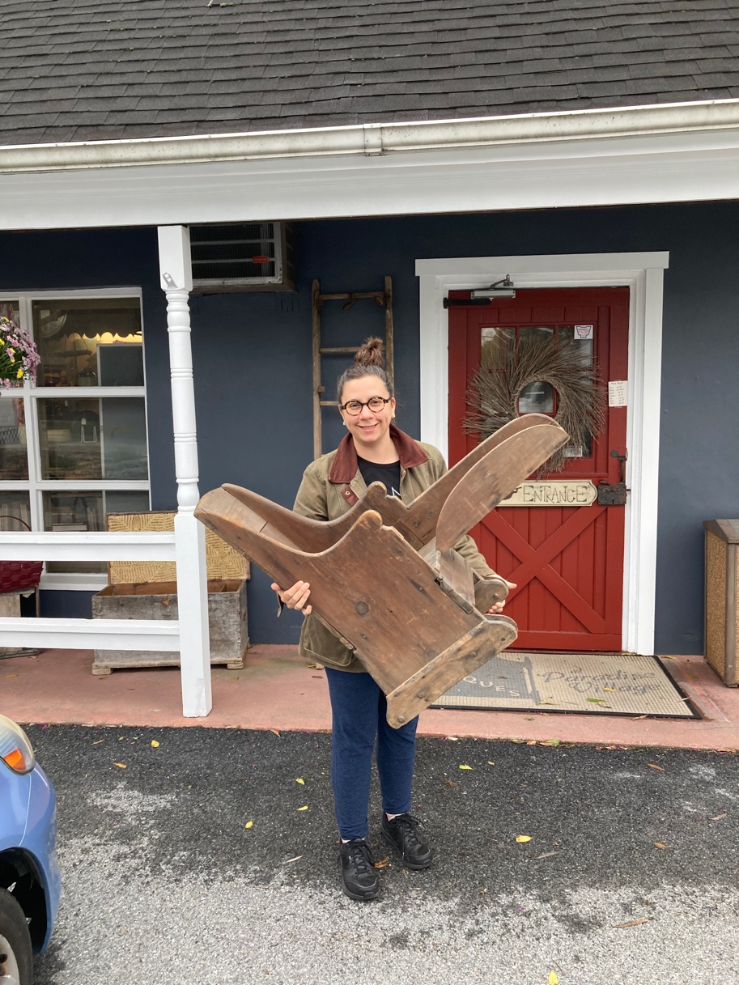
Figure 4. Author holding a chair with wheels (wheelchair) for a child outside an antique shop.
I also collect artifacts and historical photographs associated with disability history. Here I am with a recent acquisition. I bring these items to workshops and other presentations to get people talking.

Perhaps my favorite artifact to talk about is this particular crutch but also crutches in general. Crutches always surprise me. For example, I have written about a man named James Logan who identified as a “cripple” after a fall in the early eighteenth century. He wrote a lot about being “confined to crutches.” But when you consider other people who used crutches, they used them and thought about them in very different ways. Take, for example, one runaway man we can learn about from a 1799 Baltimore newspaper: “ABSCONED from the subscriber...a Negro Man named NATHAN, about 29 years of age...one leg is of no use to him in walking, it being withered, and very little larger than his arm; he hops along upon a Crutch, and a Shoemaker by trade, a good strong workman—Carried off with him a set of tools…”

Nathan didn’t see crutches as confining; he saw that as tools for getting freedom.

That’s why I usually start by talking about early American history and how relatively well-integrated and visible disabled people were in everyday life. Use this history as a reason to work toward a more disability justice-centered present and future. What will you do to make your historic sites, buildings, and landscapes more accessible for disabled people?

Below, I listed some of my favorite works of disability history and tools for access and inclusion. Please also check out the hyperlinked material above. What are your favorites? Let me know.
Douglas Baynton, Defectives in the Land: Disability and Immigration in the Age of Eugenics (Chicago: The University of Chicago Press, 2016).
Daniel Blackie, “Disability, Dependency, and the Family in the Early United States,” in Disability Histories, eds. Susan Burch and Michael Rembis: 17-34.
Dea Boster, African American Slavery and Disability: Bodies, Property, and Power in the Antebellum South, 1800-1860 (Routledge: New York, 2013).
Alima Bucciantini, “Getting in the Door is the Battle,” AASLH Blog,
American Association for State and Local History, January 22, 2019, https://aaslh.org/getting-in-the-door/.
Susan Burch and Hannah Joyner, Unspeakable: The Story of Junius Wilson (Durham: University of North Carolina Press, [2007] 2015).
Susan Burch, Committed: Remembering Native Kinship in and Beyond Institutions (Chapel Hill: University of North Carolina Press, 2021). Open access.
Daniel Göransson, “Alt-texts: The Ultimate Guide,” Axess Lab, October 15, 2017, https://axesslab.com/alt-texts/.
Aimi Hamraie, "Mapping Access: Digital Humanities, Disability Justice, and Sociospatial Practice," American Quarterly 70, 3 (2018): 455-482.
Sarah Hendron, What Can a Body Do?: How we Meet the Built World (New York: Riverhead, 2020).
Sara Hendren, and Caitrin Lynch, Engineering at Home, http://engineeringathome.org/, accessed July 21, 2022.
Judy Heumann, Being Heumann: An Unrepentant Memoir of a Disability Rights Activist (Boston: Beacon Press, 2020).
Stefanie Hunt-Kennedy, Between Fitness and Death: Disability and Slavery in the Caribbean (University of Illinois Press, 2020).
Beth Linker, War’s Waste: Rehabilitation in World War I America (Chicago: The University of Chicago Press, 2011).
Paul K. Longmore, Telethons: Spectacle, Disability, and the Business of Charity (New York: Oxford University Press, 2016).
Laura Mauldin, Disability at Home, accessed July 21, 2022, https://www.disabilityathome.org/.
Mia Mingus, “Changing the Framework: Disability Justice: How our communities can move beyond access to wholeness,” Leaving Evidence, February 12, 2011, https://leavingevidence.wordpress.com/2011/02/12/changing-the-
framework-disability-justice/.
Aparna Nair and Kylie M. Smith, “Who Would Buy Real Patient Records from Closed Asylums on eBay,” Slate, July 21, 2022, https://slate.com/technology/2022/07/vintage-asylum-records-found-on-ebay-history-of-disability.html.
Kim E. Nielsen, Money, Marriage, and Madness: The Life of Anna Ott (University of Illinois Press, 2020).

Katherine Ott, “Disability Things: Material Culture and American Disability History, 1700–2010,” in Disability Histories, eds. Susan Burch and Michael Rembis (Chicago: University of Illinois Press, 2014): 119-135.
Ellen Samuels, “Six Ways of Looking at Crip Time,” Disability Studies Quarterly 37, 3 (2017), https://dsq-sds.org/article/view/5824/4684.
James Sumner, “Adding captions (subtitles) to your video,” July 22, 2020, https://www.youtube.com/watch?v=HbkPstO6hqM&t=632s.
Jorge Matos Valldejuli, The Racialized History of Disability Activism from the “Willowbrooks of this World,” The Activist History Review, November 4, 2019, https://activisthistory.com/2019/11/04/the-racialized-history-of-disability-activism-from-the-willowbrooks-of-this-world1/.
National Center on Disability Journalism, “Disability Language Style,” https://ncdj.org/style-guide/.
Bess Williamson, Accessible America: A History of Disability and Design (New York: New York University Press, 2019).
Alice Wong, ed., Disability Visibility: First-Person Stories from the 21st Century (New York: Vintage, 2020).

“Fifty Dollars Reward,” American (published as American And Daily Advertiser) (Baltimore, MD), December 28, 1799, page 8. America’s Historical Newspapers.

